Week 3
SD-WAN Implementation Documentation
Introduction & Purpose of SD-WAN
SD-WAN (Software-Defined Wide Area Network) is an advanced solution for managing WAN networks that provides:
- The ability to combine multiple internet connections (WAN links) for smart traffic distribution.
- Quality-based routing to optimize traffic depending on the service type (e.g., VoIP, Video, Web).
- Automatic failover if one link goes down, ensuring uninterrupted user experience.
- Load balancing to utilize all available links efficiently.
- Continuous performance monitoring (latency, jitter, packet loss) to improve network reliability.
In short: SD-WAN makes the network more intelligent, flexible, and reliable compared to a single fixed WAN link.

Project Environment
- Number of Internet Links: 2 WAN links
- Local Network: 10.10.10.0/24
- Device: FortiGate Firewall
- Goal: Route internal traffic to the internet efficiently and manage traffic based on service type (e.g., VoIP calls, YouTube streaming).
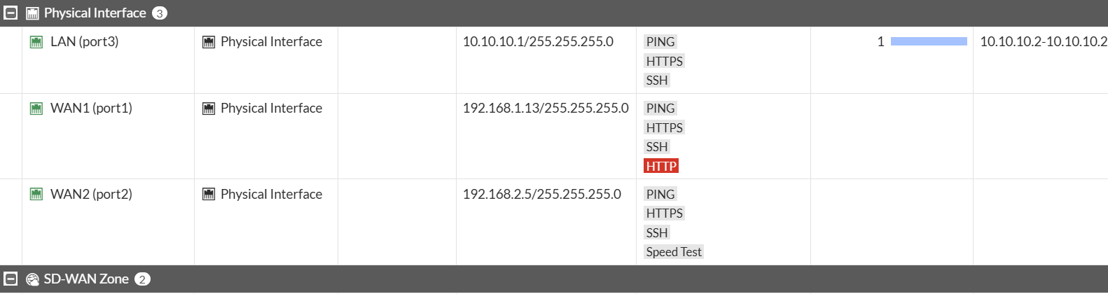

Implementation Steps
Step 1: Verify Initial Configuration
- Checked Firewall Policies: No policies are active.
- Checked Routing: No static routes or default routes exist.
- Purpose: Ensure a clean environment before enabling SD-WAN.
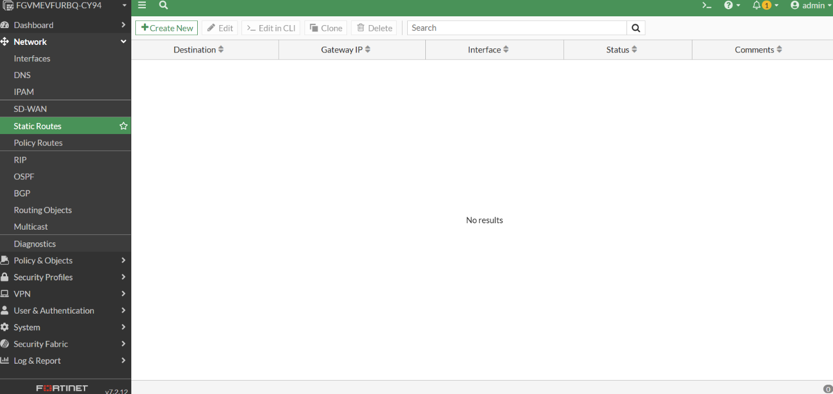

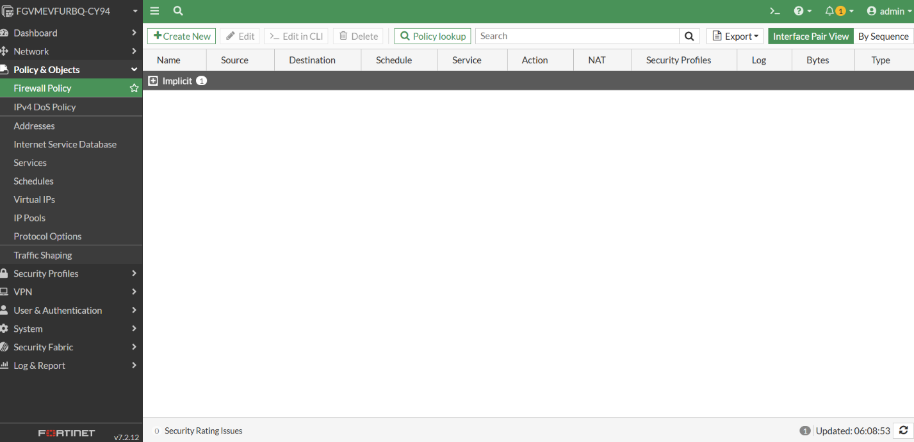

Step 2: Add Internet Links as SD-WAN Members
- Each WAN link is added as a Member inside SD-WAN:
  - WAN1 → Member 1
  - WAN2 → Member 2
- Purpose: Integrate all WAN links under a single SD-WAN zone for centralized management.
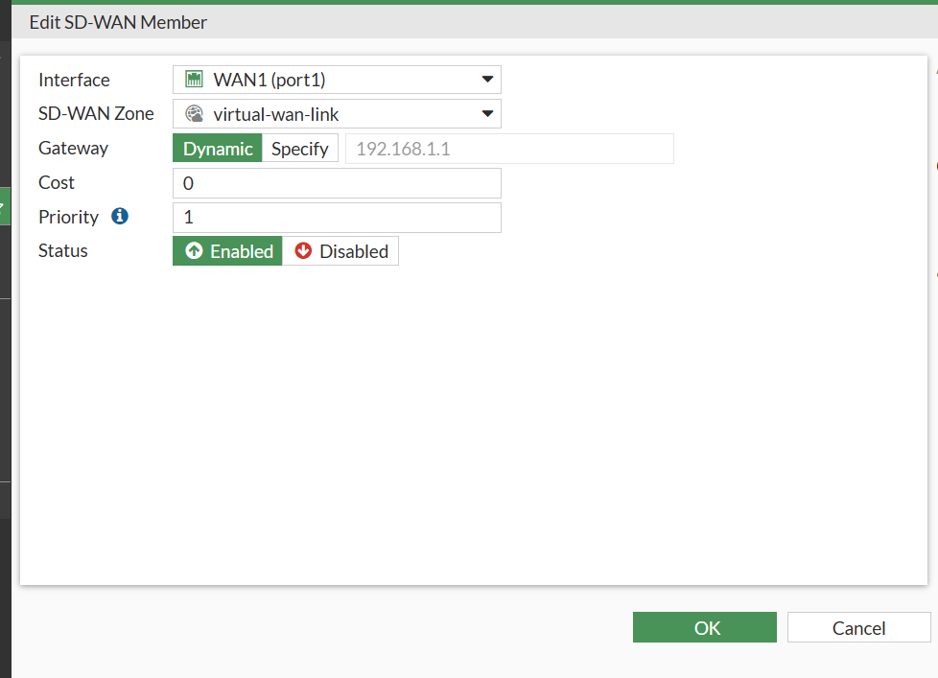
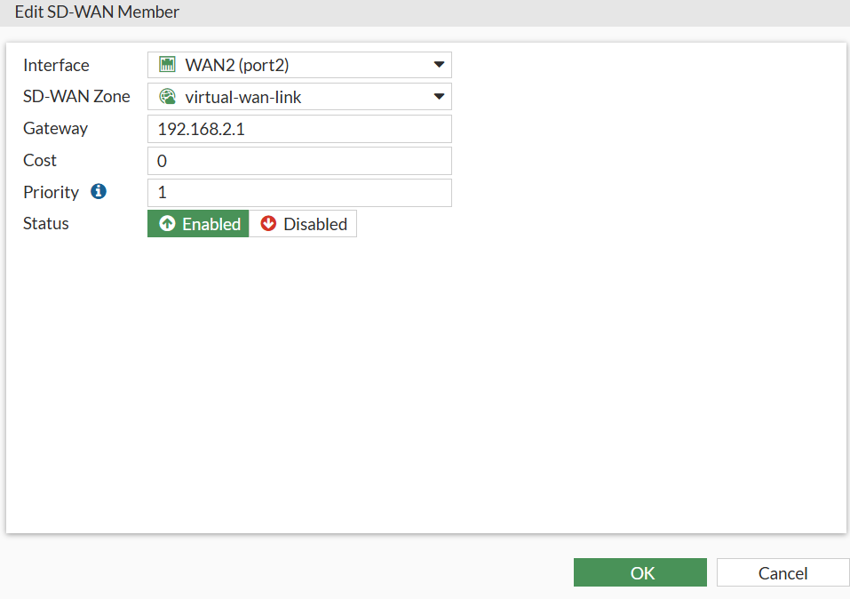
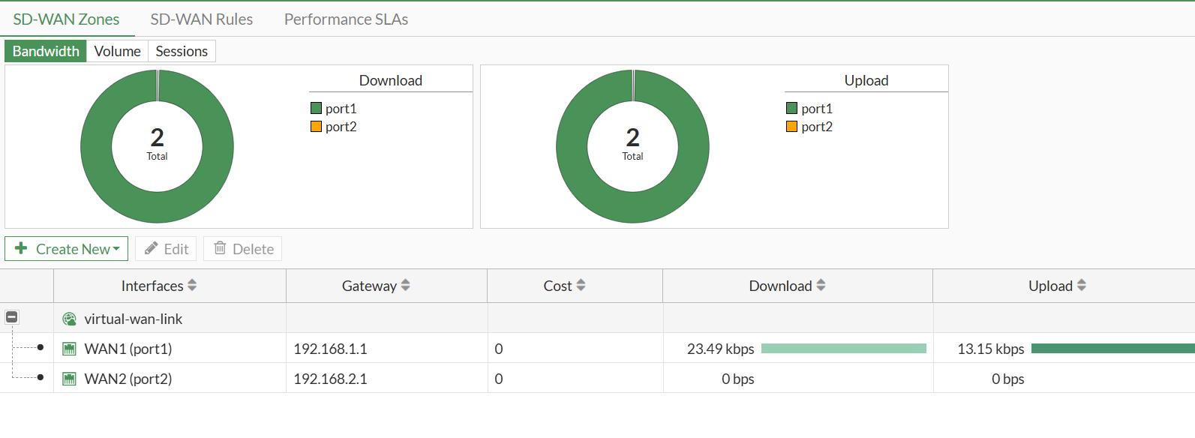

Step 3: Create SD-WAN Zone
- Created a SD-WAN Zone named SD-WAN-Zone.
- Added all WAN members (WAN1, WAN2) into this zone.
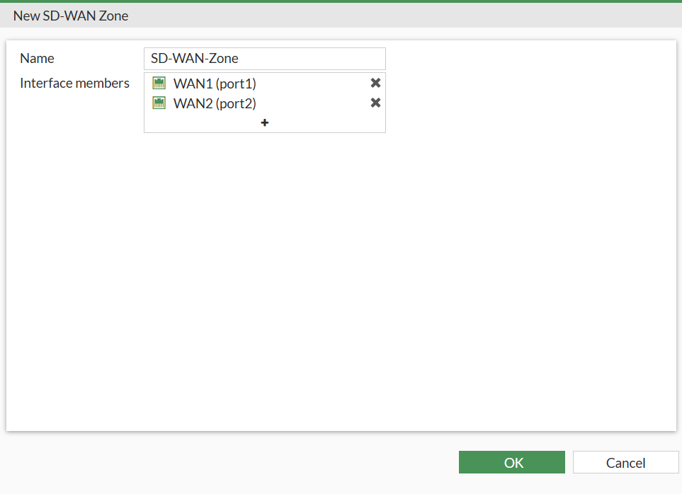

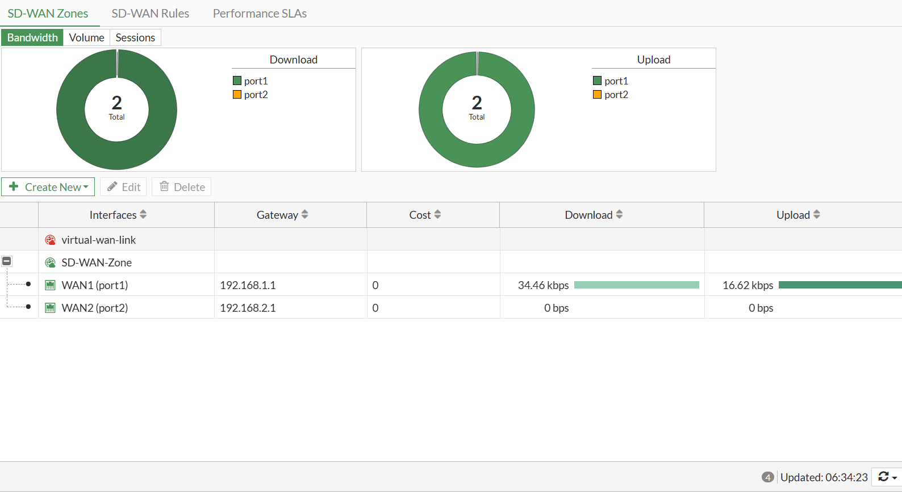

Step 4: Configure Default Static Route
- Static Route Configuration:
  - Destination: 0.0.0.0/0
  - Interface: SD-WAN-Zone
- Purpose: Direct all outbound traffic through the SD-WAN zone instead of individual WAN interfaces.
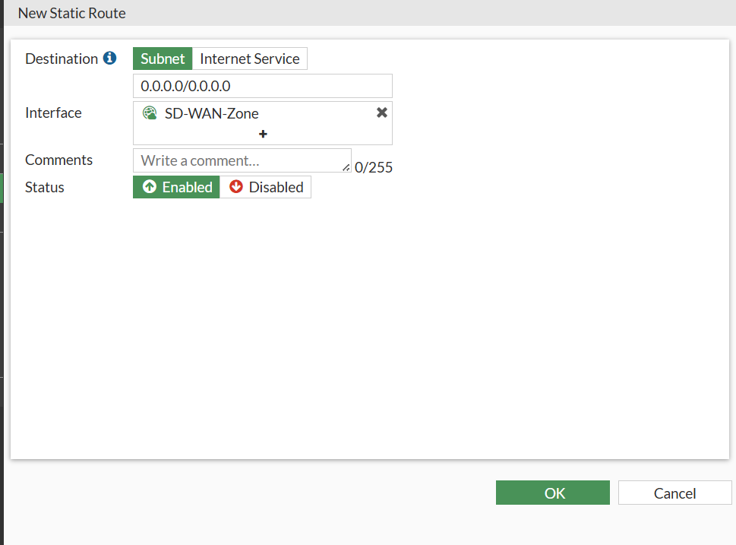

Step 5: Configure Firewall Policy
- Created a firewall policy named Internet Access:
  - Incoming Interface: LAN
  - Outgoing Interface: SD-WAN-Zone
  - Source: Local Subnet 10.10.10.0/24
  - Destination: All
  - Schedule: All
  - Service: All
- Purpose: Ensure internal traffic exits to the internet via the SD-WAN zone.

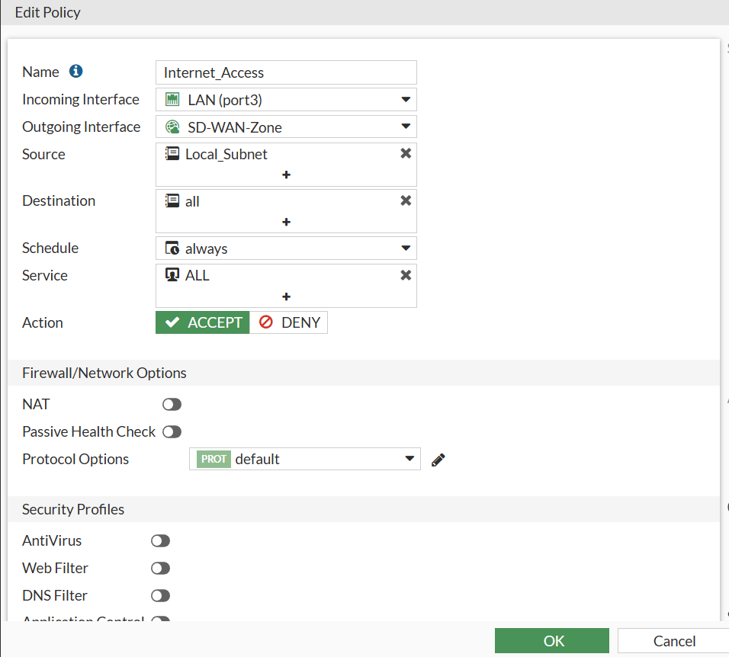

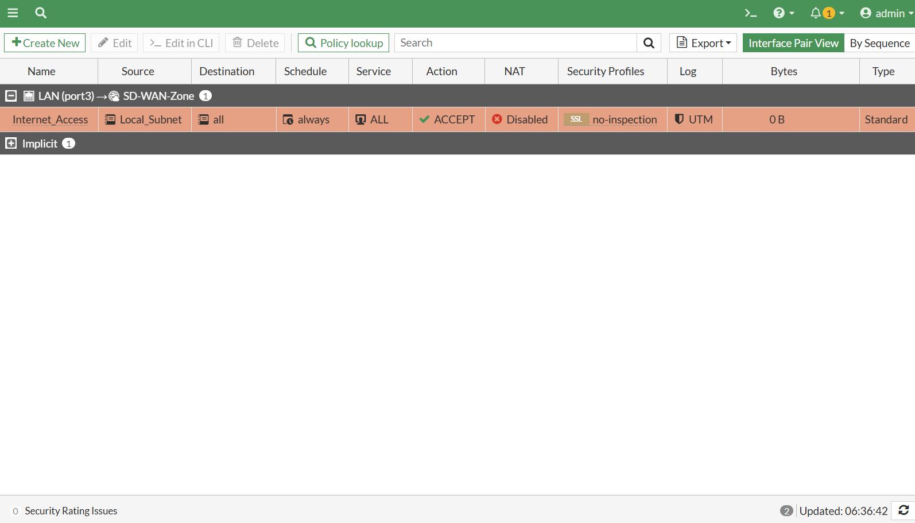

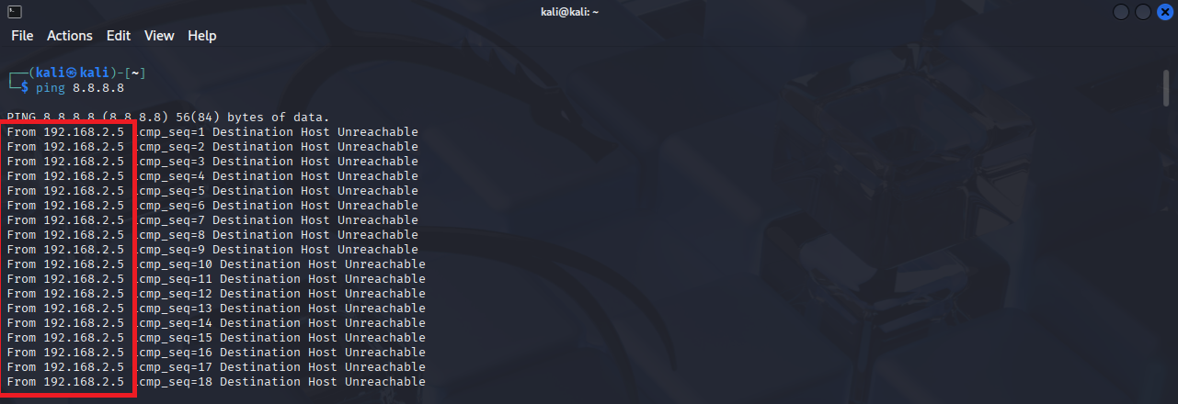

Step 6: Configure Performance SLA
- Name: Internet_Link_Check
- Probe Mode: Prefer Passive
- Protocol: Ping
- Servers: 8.8.8.8, 4.4.2.2
- Participated Members: All SD-WAN Members
- SLA Targets:
  - Latency: 200ms
  - Jitter: 50ms
  - Packet Loss: 5%
- Purpose: Monitor link quality and enable intelligent routing decisions based on performance.
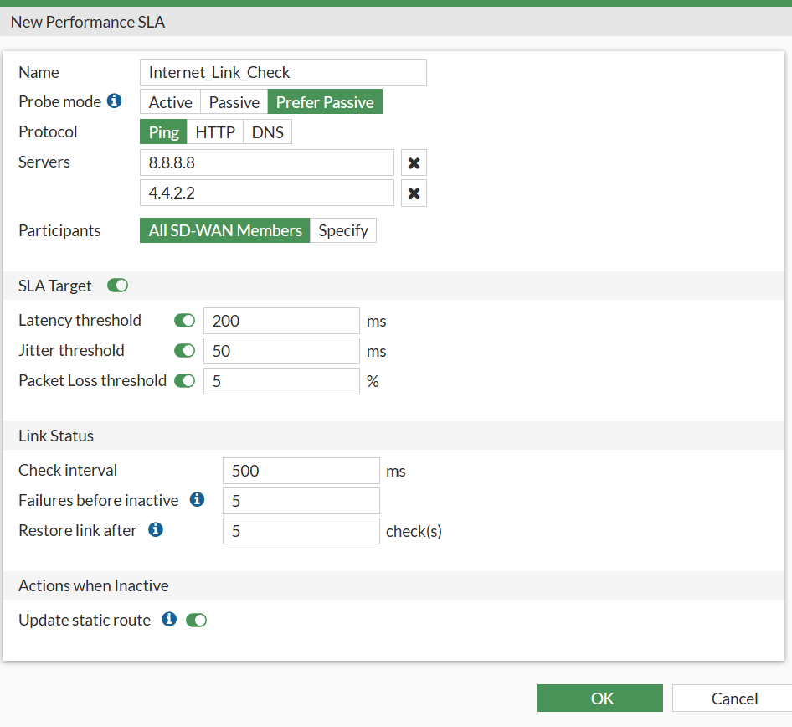

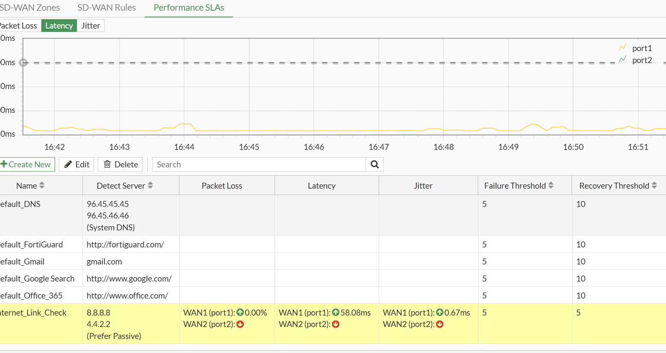

Step 7: Create SD-WAN Rules
- Example rules implemented:
  - Traffic from subnet 10.10.10.0/24 to YouTube → routed via WAN1
  - Traffic from subnet 10.10.10.0/24 for VoIP calls → routed via the best performing link automatically
- Purpose: Direct traffic efficiently based on application type and link quality.

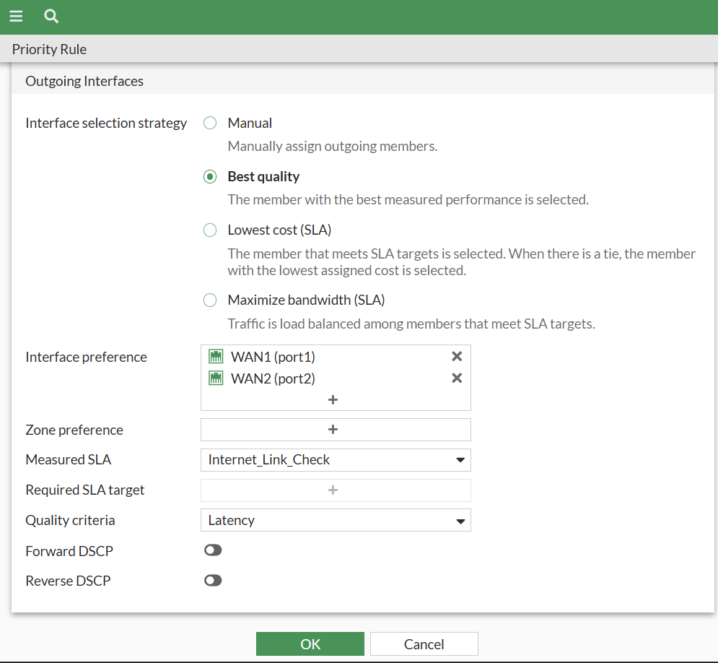

Step 8: Load Balancing Configuration
- Mode: Source-IP based
- Purpose: Distribute traffic across WAN links evenly while keeping sessions consistent per source IP.
- Configured in GUI (or optionally CLI for mode selection).
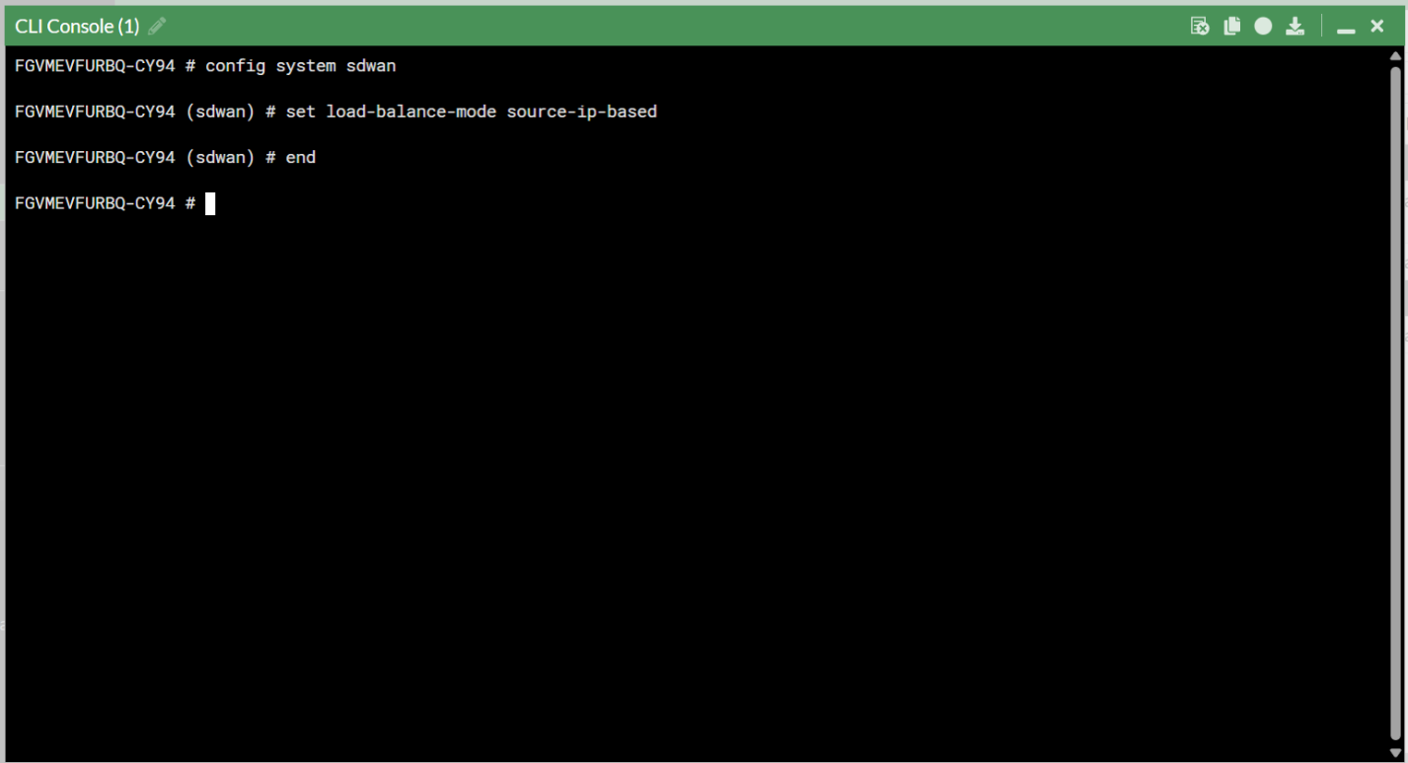

Step 9: Testing & Monitoring
- Observed SD-WAN member status:
  - WAN1: Up
  - WAN2: Down
- Tested traffic routing for YouTube and VoIP services to verify SLA rules and best-quality routing.
- Verified failover functionality by simulating WAN link failure.
- Monitored latency, jitter, and packet loss via SD-WAN Monitor dashboard.
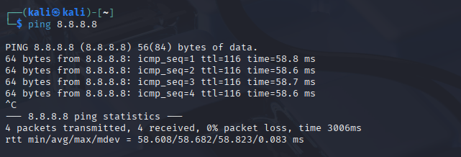

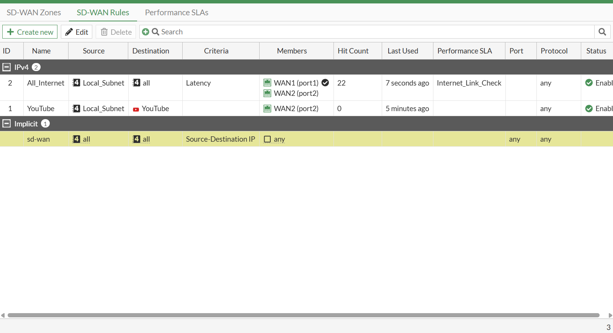

Conclusion
The SD-WAN implementation provides:
- Intelligent routing and application-aware traffic steering.
- Automatic failover for uninterrupted connectivity.
- Efficient utilization of all WAN links with load balancing.
- Real-time performance monitoring for proactive network management.

Mohab Nasser

